Topics for midterm
1. Time complexity- iterative + Recursive
For recursive complexity (Use this masters theorem)-
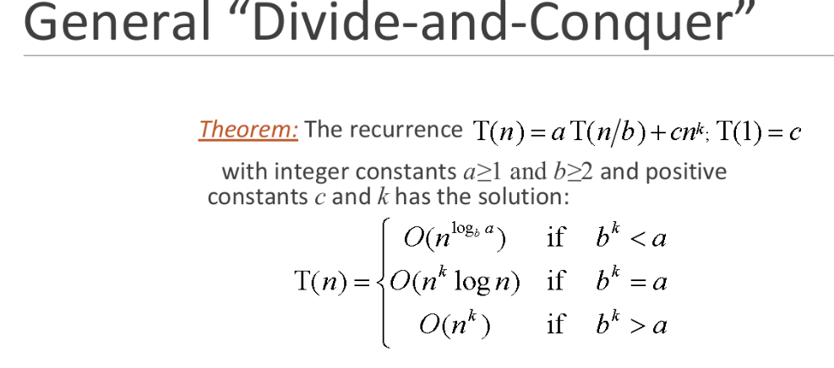
2. Assymptotic notation
3. Searching

Binary Search-
Time Complexity: O(log₂ n)
Space Complexity: O(1) (iterative), O(log n) (recursive)
Use Cases:
Search element in sorted array
Find lower or upper bound
Find first or last occurrence of an element
Find peak in a 1D array
Search in rotated sorted array
Find minimum element in rotated array
Determine square root or cube root of a number

Ternary Search -
Time Complexity: O(log₃ n)
Space Complexity: O(1) (iterative), O(log n) (recursive)
Use Cases:
Finding maximum/minimum of a unimodal function
Optimization problems (e.g., find best time/cost)
Peak element in unimodal sequences
Binary Search is more efficient in discrete and sorted search problems.

3. Sorting Algorithm O(n²)-
1. Selection Sort

Strengths:
Performs well on small datasets
Does minimum number of swaps (useful if swap operation is costly)
Use When:
Array is small and memory writes are expensive
Stable? ✅ Yes

📌 2. Bubble Sort
Strengths:
Can detect early sorted arrays with optimization (early exit)
Use When:
Teaching basic sorting logic
Very small or almost sorted data
Stable? ✅ Yes

📌 3. Insertion Sort
Strengths:
Efficient for small or nearly sorted datasets
Use When:
Data is nearly sorted
Small arrays (e.g., as part of hybrid sorts like TimSort)
Stable? ✅ Yes

📌 4. Counting Sort

Strengths:
Extremely fast for small integer keys with limited range
Linear time: O(n + k) (k = range of values)
Use When:
Keys are small integers in a limited range
Non-comparison-based sorting is acceptable
Stable? ✅ Yes (if implemented carefully)

Sorting algorithm based on Divide and conquer approach-
📌 5. Merge Sort
Strengths:
Guaranteed O(n log n) time
Works well with linked lists and external sorting (disk-based)
Use When:
Stability is required
Stable? ✅ Yes

📌 6. Quick Sort
Strengths:
Fast in practice on average: O(n log n)
In-place with low memory usage
Use When:
Memory is limited
Average case performance is more important than worst-case
Stable? ❌ No
Divide and Conquer Algorithm

Find the maximum sum of any contiguous subarray in a given array.

🔍 Divide and Conquer Strategy:
- Divide the array into two halves.
- Recursively compute:
  - Maximum subarray sum in the left half
  - Maximum subarray sum in the right half
  - Maximum subarray sum crossing the middle
- The final answer is the maximum of the three.

🕒 Time Complexity: O(n log n)

💡 Kadane's is better (O(n))
🔍 Use it when:

You need to find a maximum profit, score, or signal segment
E.g., stock prices, temperature changes, signal processing, etc.

The input is a 1D array of integers, and you’re asked to find:

Largest sum of a contiguous subarray

Most profitable time interval

Best continuous performance streak

Longest positive streak with max impact

You want efficiency:
Use Kadane’s algorithm for linear-time performance: O(n)

You are solving problems like:

Maximum subarray (LeetCode, HackerRank)

Stock Buy-Sell (1 transaction)

Heatwave detection

Peak gain/loss segment in performance data

📌 2. Karatsuba Multiplication using Divide and Conquer

🧠 Problem:
Multiply two large numbers more efficiently than the traditional O(n²) method.

🕒 Time Complexity: O(n^log₂3) ≈ O(n^1.585)

🔍 Use it when:

You need to multiply very large integers efficiently
(e.g., thousands or millions of digits)

The built-in multiplication is too slow or not allowed
E.g., custom BigInteger implementation or programming competition

You're working in domains like:

Cryptography (e.g., RSA encryption uses big number multiplication)

Arbitrary-precision arithmetic

Competitive programming (manual big number multiplication)

You want faster multiplication than the naive O(n²) approach

Karatsuba runs in O(n^1.585), significantly faster for large numbers

📘 1. What is a Graph?

✅ Definition:
A graph is a mathematical structure used to model pairwise relationships between objects. It
consists of:
- A set of vertices (nodes)
- A set of edges (links) connecting pairs of vertices

✅ Notation:
A graph G is defined as:
G=(V,E)G = (V, E)G=(V,E)
- V = set of vertices
- E = set of edges (e.g., (u, v) pairs)

🌐 2. Types of Graphs

Type | Description
Undirected Graph | Edges have no direction (i.e., (u, v) and (v, u) are the same)
Directed Graph (Digraph) | Edges have direction (i.e., (u → v) ≠ (v → u))
Weighted Graph | Each edge has a weight or cost
Unweighted Graph | All edges are treated equally
Cyclic Graph | Contains at least one cycle
Acyclic Graph | No cycles (e.g., trees, DAGs)
Connected Graph | There's a path between every pair of vertices (for undirected graphs)
Complete Graph | Every pair of distinct vertices is connected
Bipartite Graph | Vertices can be divided into 2 disjoint sets with no edges inside a set

🧠 3. Graph Representation
Graphs can be represented in several ways depending on the problem:

📄 A. Adjacency Matrix
Description | A 2D matrix adj[i][j] indicates presence of edge between vertex i and j
Space | O(V²)

# Example: 3 vertices, undirected graph
adj_matrix = [
[0, 1, 0],
[1, 0, 1],
[0, 1, 0]
]

📄 B. Adjacency List
Description | Each vertex has a list of adjacent vertices
Space | O(V + E) – efficient for sparse graphs

# Undirected graph with 3 vertices
adj_list = {
0: [1],
1: [0, 2],
2: [1]
}

✅ Summary Comparison
Representation | Space Complexity | Fast Edge Lookup? | Best for
Adjacency Matrix | O(V²) | ✅ O(1) | Dense graphs, small graphs
Adjacency List | O(V + E) | ⚠️ Slower | Sparse graphs, large graphs

🔍 1. Breadth-First Search (BFS)

📘 Definition:
BFS is a graph traversal algorithm that explores all nodes at the current depth before moving to
the next level.

✅ Key Characteristics:
- Uses queue (FIFO)
- Explores neighbors level by level
- Works on graphs and trees
- Handles disconnected graphs by looping through all nodes

🕒 Time Complexity: O(V + E)
(V = vertices, E = edges)

🎯 Use Cases:
- Shortest path in unweighted graphs
- Level-order traversal of trees
- Flood-fill algorithms (e.g., in games or paint programs)

🧩 2. Bipartite Graph / Bicolorable Graph

📘 Definition:
A graph is bipartite if you can color its nodes using 2 colors such that no two adjacent node
s have the same color.

✅ Key Characteristics:
- No odd-length cycles
- Can be divided into two independent sets
- Can be checked using BFS with coloring

🕒 Time Complexity: O(V + E)

🎯 Use Cases:
- Matching problems (e.g., job assignment)
- 2-coloring of graphs
- Checking feasibility of dividing people into 2 non-conflicting groups

🔁 3. Cycle Detection in Undirected Graph using BFS

📘 Definition:
Detect whether an undirected graph contains a cycle by checking if a node is revisited not from
its parent.

✅ Key Characteristics:
- Track each node’s parent
- If you visit a visited neighbor that’s not the parent, it’s a cycle

🔍 BFS Algorithm for Cycle Detection:

🕒 Time Complexity: O(V + E)

🎯 Use Cases:
- Validate tree structure (tree has no cycles)
- Network/mesh design (e.g., no loops)
- Prevent infinite loops in system design

✅ Quick Summary Table
Concept | Key Tool | Use For | Time Complexity | Notes
BFS | Queue (FIFO) | Shortest path, level-order, flood-fill | O(V + E) | Good for unweighted graph traversal
Bipartite Graph Check | BFS + Color | 2-colorability, group division | O(V + E) | No odd-length cycles
Cycle Detection (Undirected) | BFS + Parent | Validate tree, detect loops | O(V + E) | If visited node ≠ parent, cycle exists

